Question 1

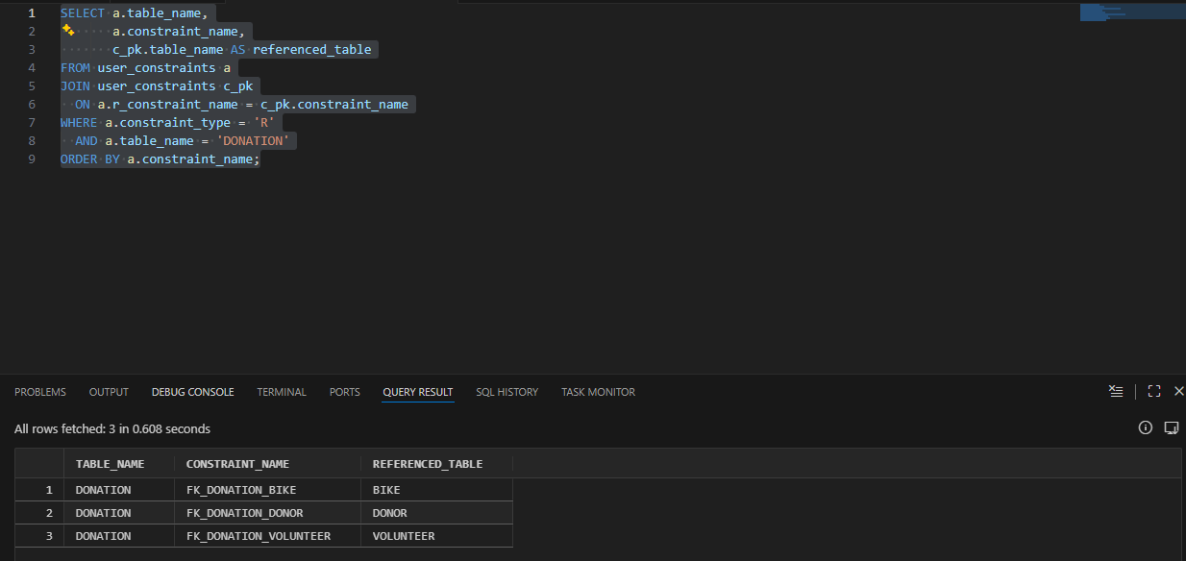
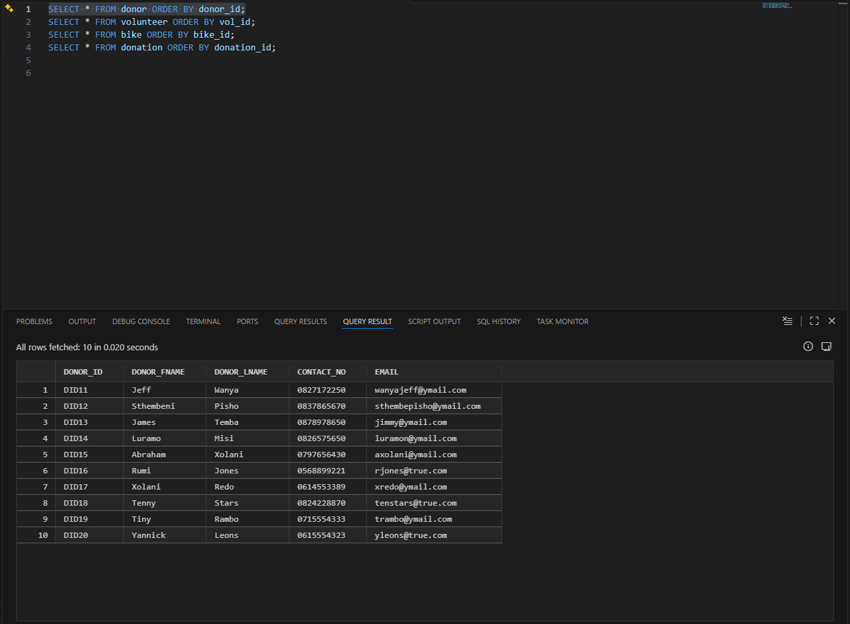
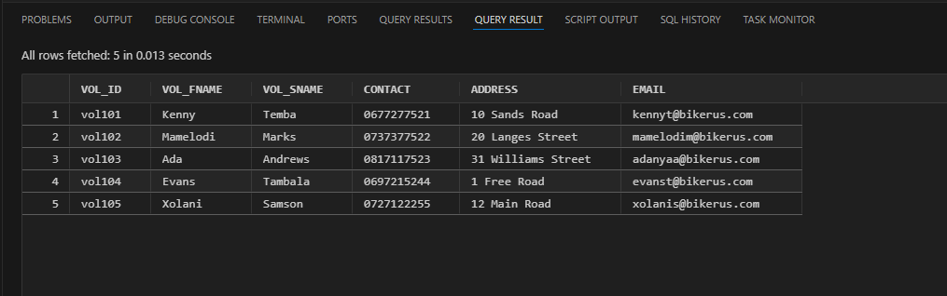
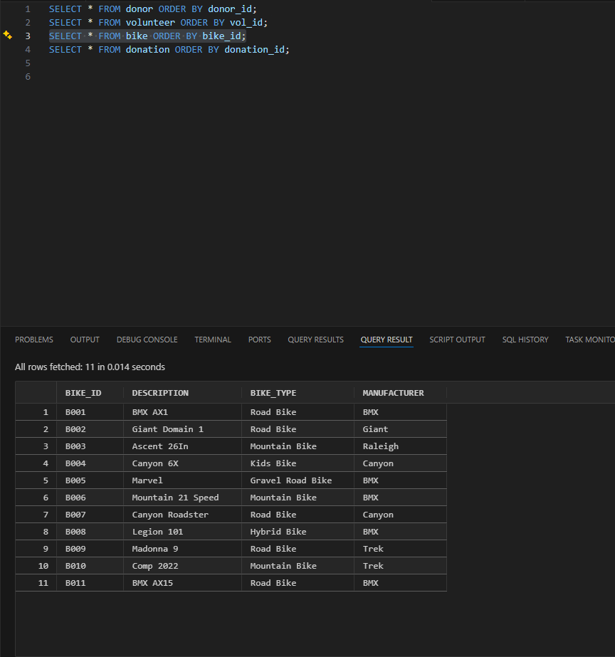
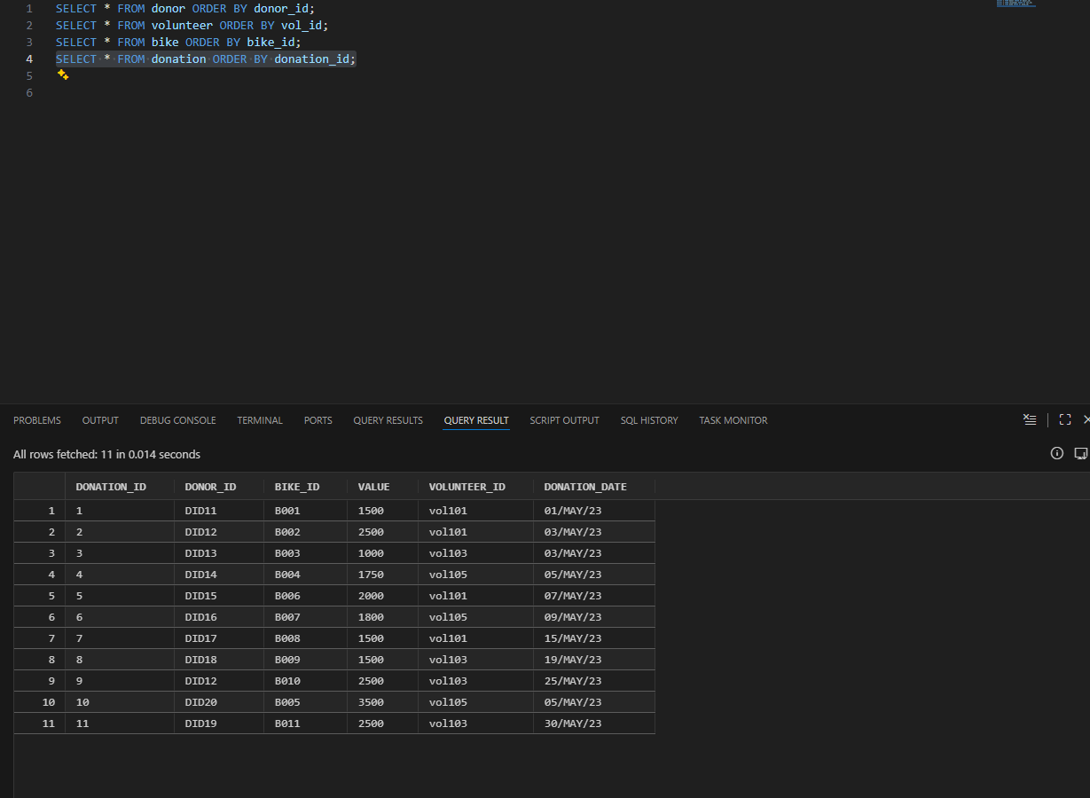

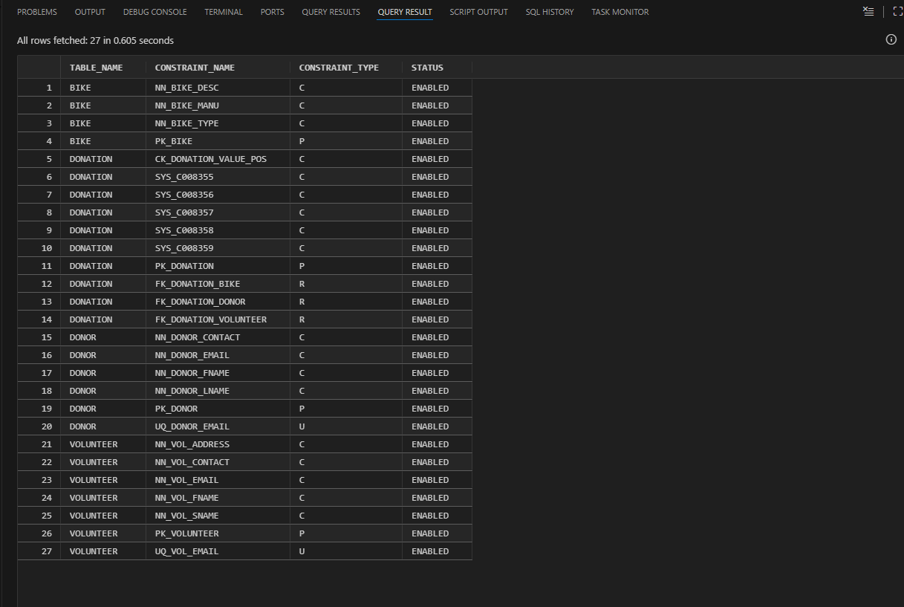

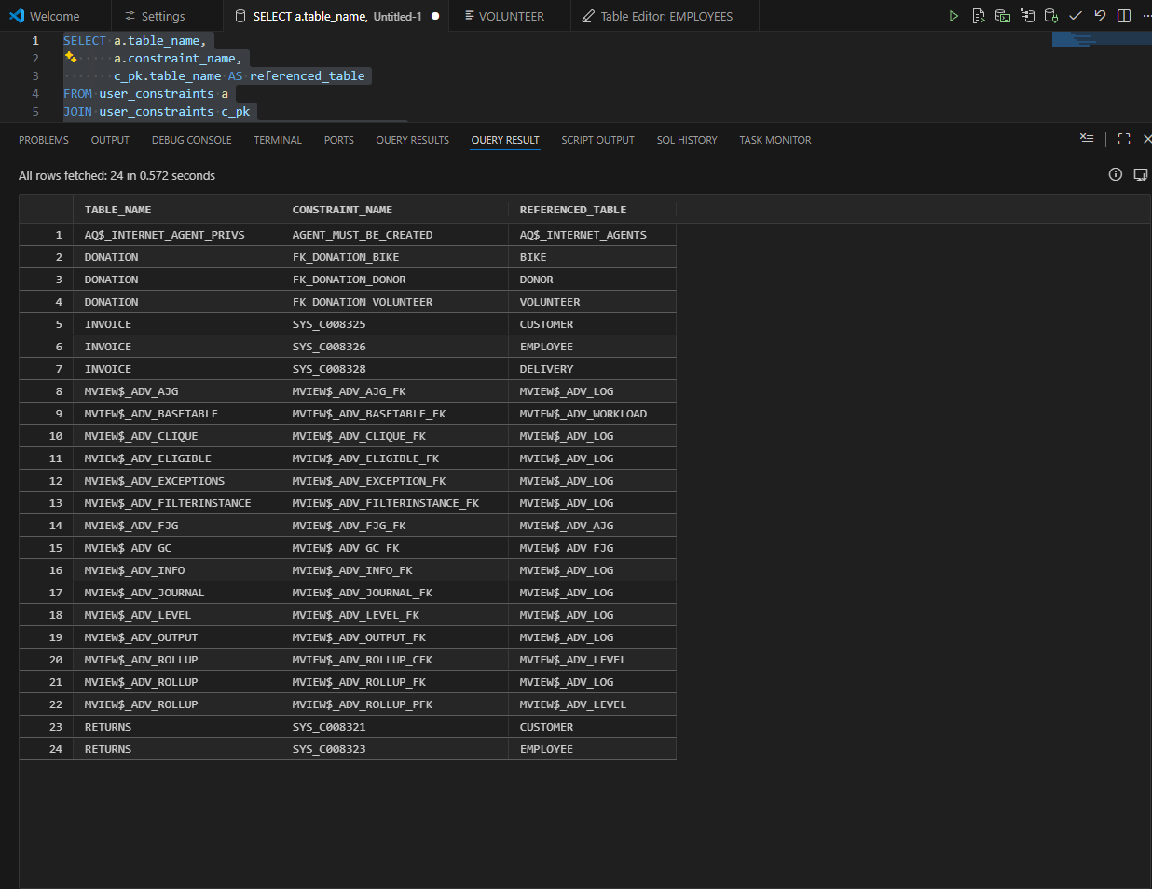
Question 2
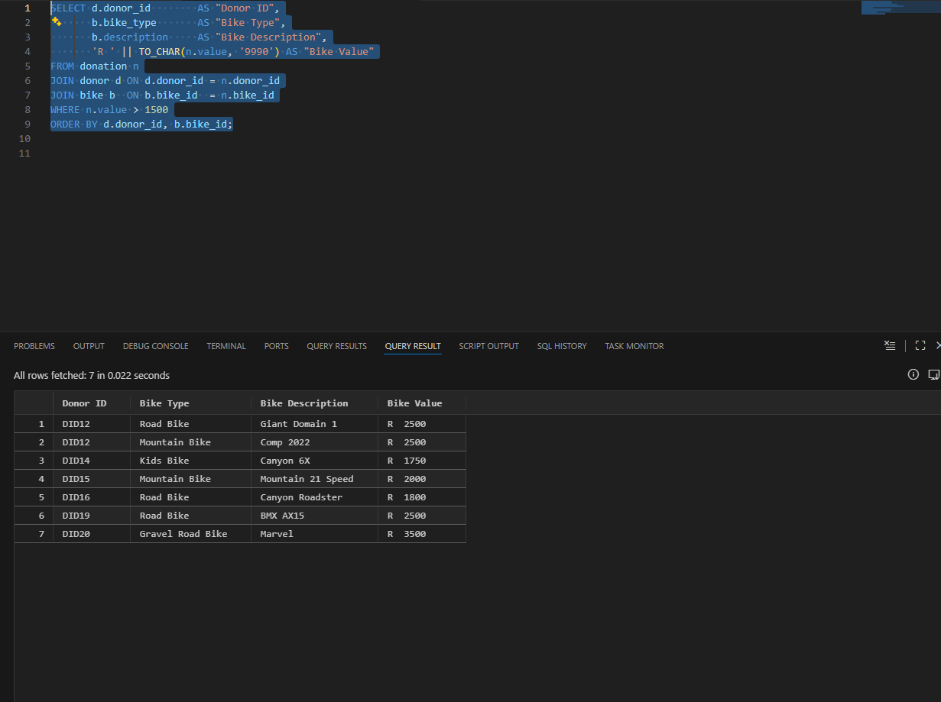
Question 3
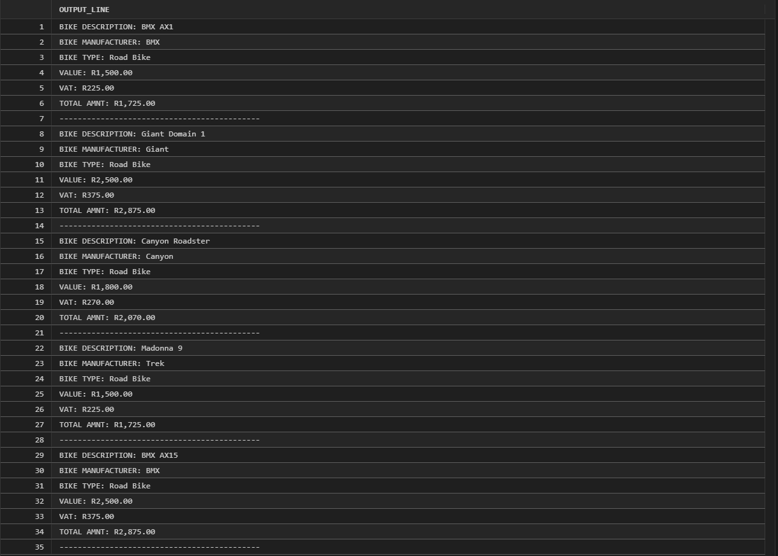
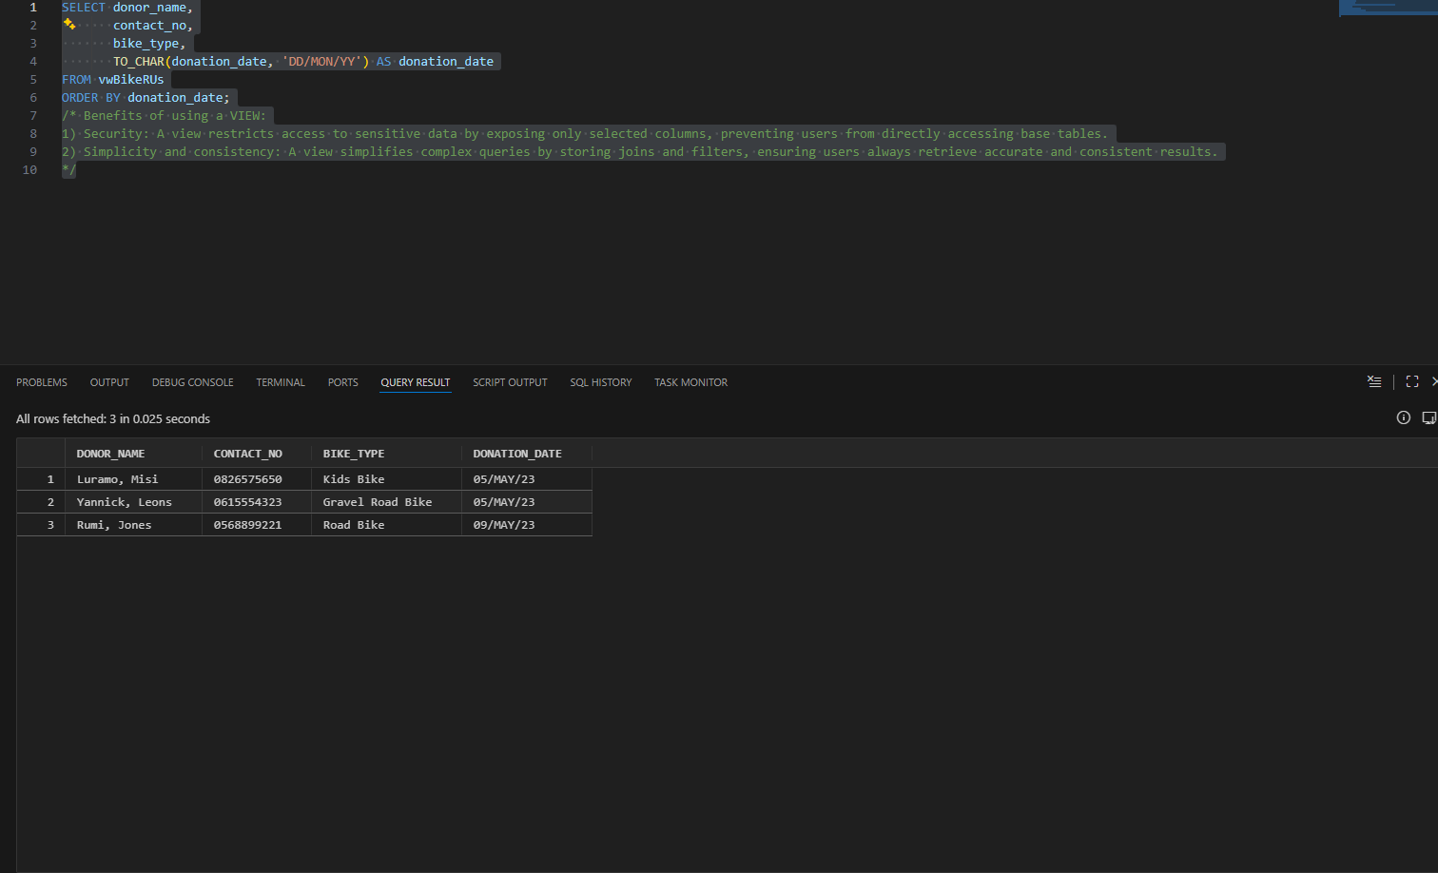
Question 4

Question 5
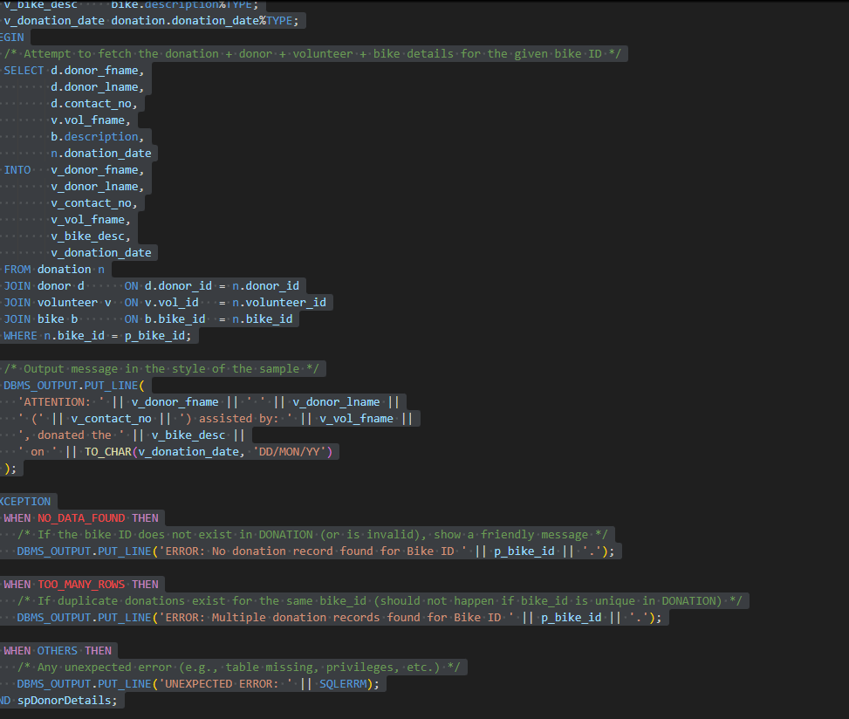
Comments for question 5 (forgot to add during the project)
-- Exception handling ensures the procedure does not crash if invalid data is supplied.
-- NO_DATA_FOUND handles cases where the provided bike ID does not exist in the database.
-- OTHERS captures any unexpected runtime errors and displays a user-friendly message.

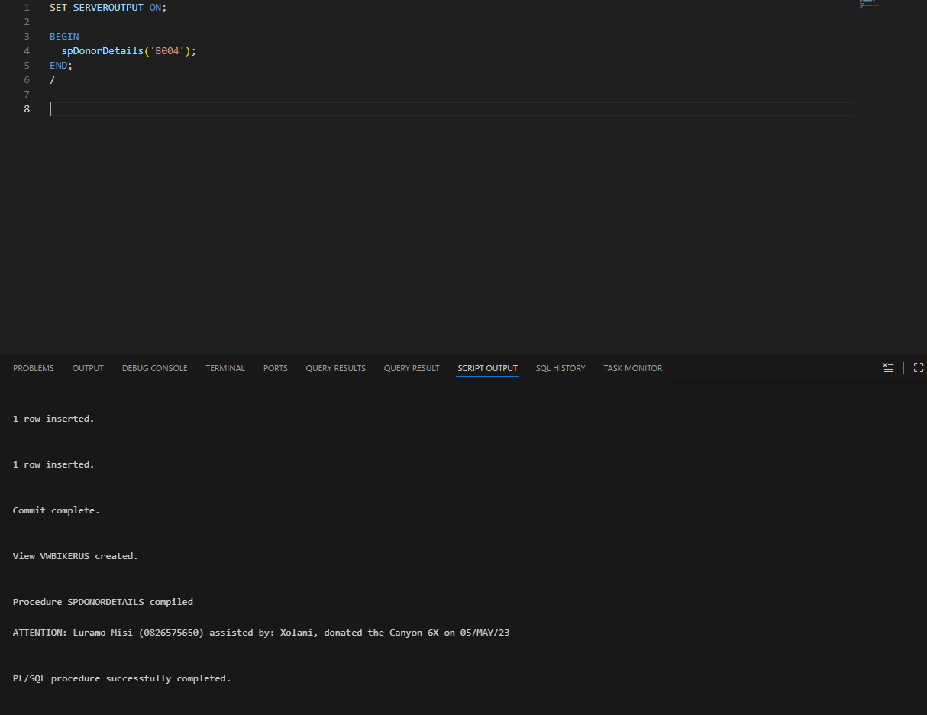
Question 6
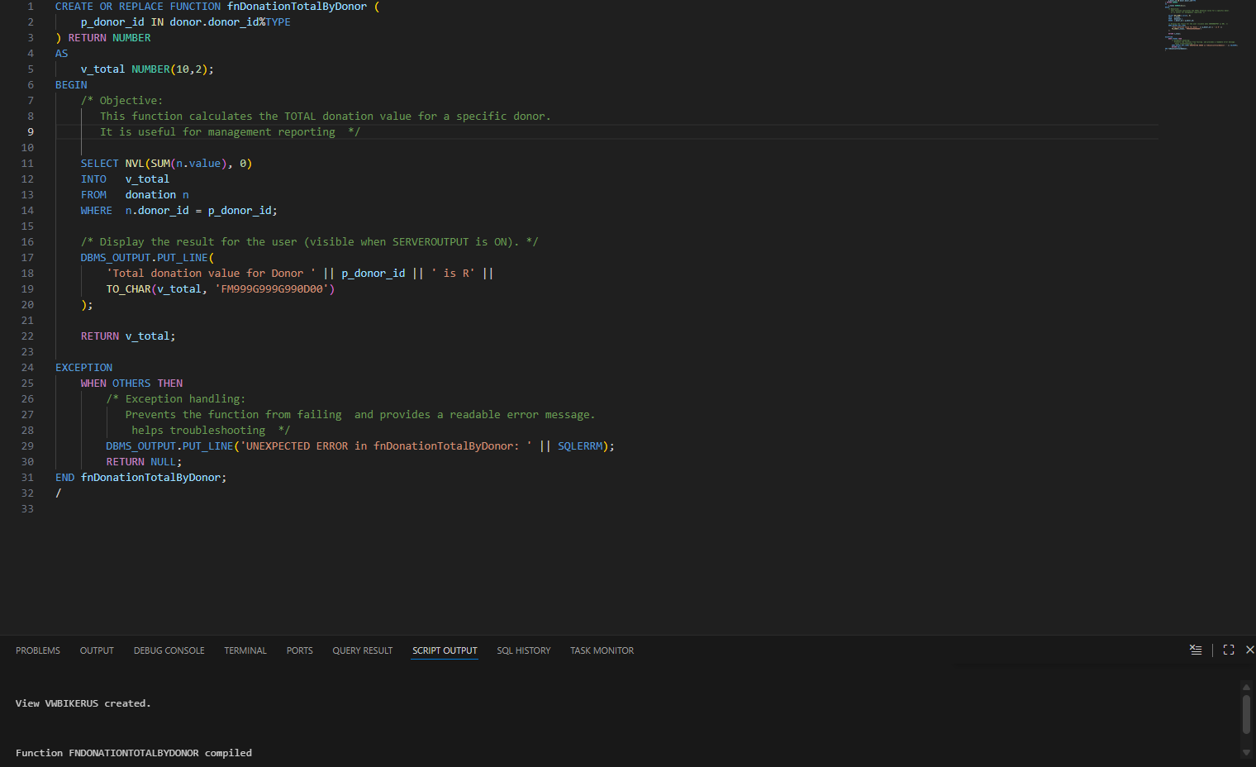
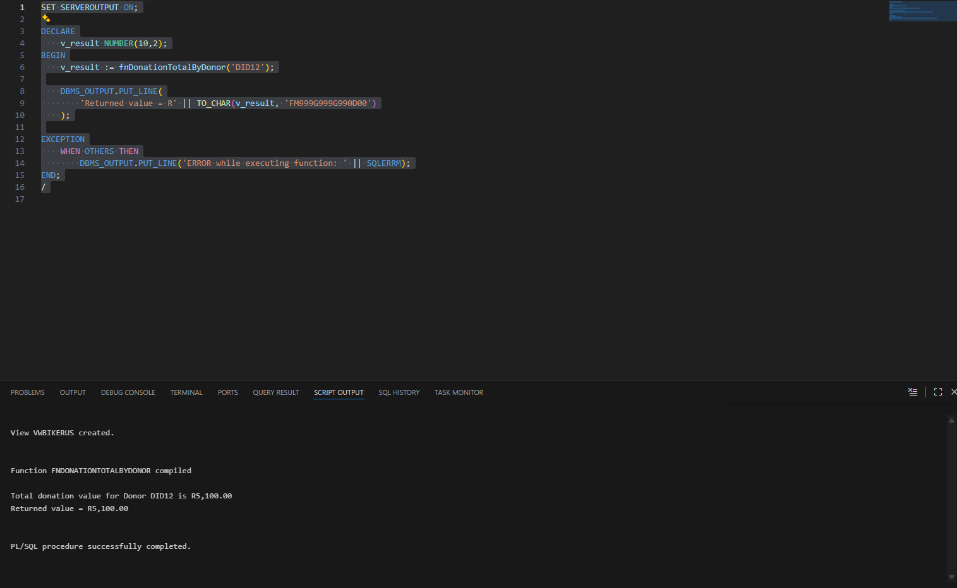

Question 7

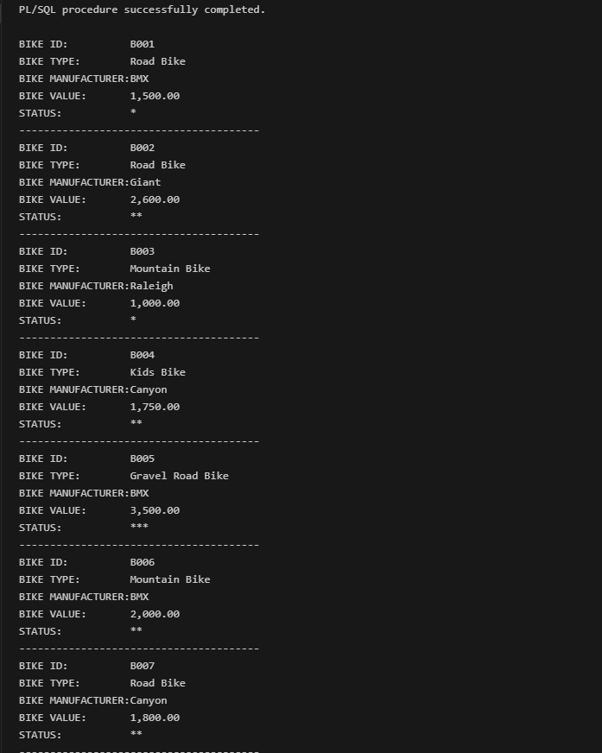
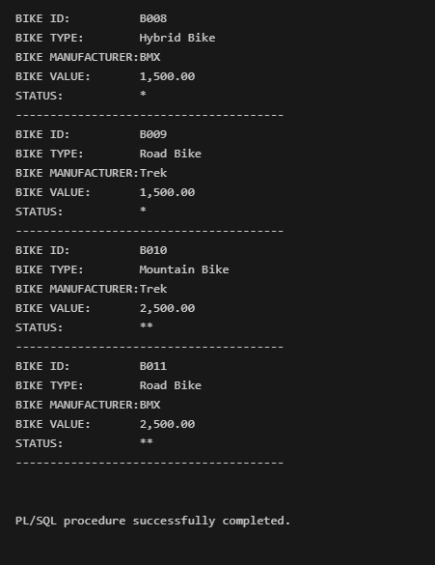
Question 8
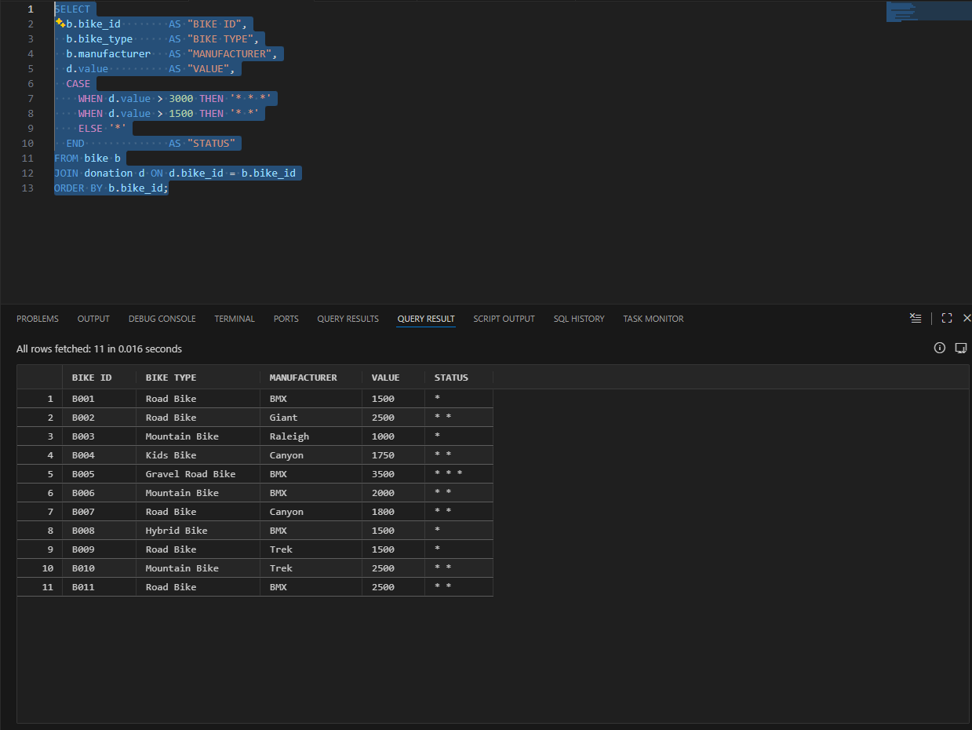
Question 9
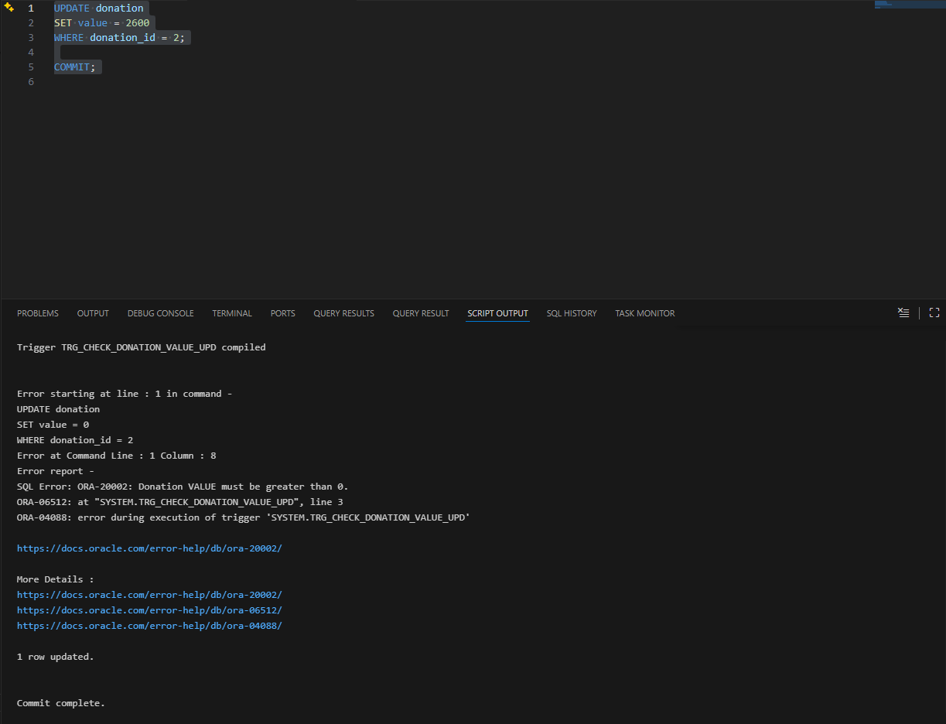

Question 10
Confidentiality, Integrity and Availability at BikesRUs
The BikesRUs database is used to store information about donors, volunteers, bikes and donations. This information is important for the organisation to function properly, but some of it is also private. For example, donor contact details and donation values should not be visible to everyone. Because of this, the database needs to be protected so that data is not misused, changed incorrectly or lost.
To protect the data, BikesRUs follows the three main database security principles, which are confidentiality, integrity and availability. These principles focus on different ways of keeping the data safe.

Confidentiality
Confidentiality is mainly about privacy. It makes sure that sensitive information is only seen by people who are allowed to see it. At BikesRUs this includes donor phone numbers, email addresses and how much was donated. If this information was accessed by the wrong person, it could cause problems for both the donors and the organisation.
One way confidentiality can be controlled in Oracle XE is by using roles. Roles make it easier to manage user access because not every user needs full permissions. For example, someone who only views reports should not be able to change data in the database.
CREATE ROLE report_user;
GRANT SELECT ON donor TO report_user;
GRANT SELECT ON donation TO report_user;
A different method that can be used to protect privacy is the use of views. Views allow users to see only certain columns instead of the full table. This helps hide sensitive information while still allowing useful data to be accessed. For example, a view can show donor names and bike types without showing contact details.
CREATE OR REPLACE VIEW vwPublicDonations AS
SELECT donor_fname, donor_lname, bike_type
FROM donor d
JOIN donation n ON d.donor_id = n.donor_id;
This reduces the risk of sensitive data being exposed by mistake.

Integrity
Integrity is about making sure the data in the database stays correct. This means values must be valid and tables must remain properly linked. For BikesRUs, this is important because donation records should always be accurate and trustworthy.
Oracle XE uses constraints to help with this. Primary keys make sure records are unique, and foreign keys make sure that donations are linked to valid donors, bikes and volunteers.
FOREIGN KEY (donor_id) REFERENCES donor(donor_id)
There is also a rule that donation values must be greater than zero. This is enforced using a CHECK constraint, which prevents invalid values from being entered.
CHECK (value > 0)
Triggers are another way to protect data integrity. In Question 9, triggers were used to stop donation records from being deleted and to prevent incorrect updates. This helps protect important data from being changed accidentally.

Availability
Availability means that the database should be accessible when it is needed. At BikesRUs, staff use the database for daily tasks such as recording donations and checking bike information. If the database is unavailable, work cannot continue properly.
One way to help with availability is by doing regular backups. Oracle XE supports backups using Data Pump Export, which allows data to be recovered if something goes wrong.
expdp system/password schemas=SYSTEM directory=backup_dir dumpfile=bikerus.dmp
Transaction control is also important. Using COMMIT and ROLLBACK ensures that mistakes can be undone and the database is not left in an unstable state.
COMMIT;
ROLLBACK;
Availability is also improved through exception handling in procedures and functions. When errors are handled properly, the system can continue running instead of stopping completely.
EXCEPTION
WHEN OTHERS THEN
DBMS_OUTPUT.PUT_LINE(SQLERRM);

Conclusion
By using roles, views, constraints, triggers, backups and exception handling, BikesRUs is able to protect its database effectively. These methods help keep information private, accurate and available when needed. Together, they support the safe and reliable use of the database in daily operations.

Referencing
Oracle Corporation (2023) Oracle Database SQL Language Reference. Available at:
https://docs.oracle.com/en/database/oracle/oracle-database/21/sqlrf/
(Accessed: 30 September 2025).
Oracle Corporation (2023) Oracle Database PL/SQL Language Reference. Available at:
https://docs.oracle.com/en/database/oracle/oracle-database/21/lnpls/
(Accessed: 30 September 2025).
Oracle Corporation (2023) Managing Database Security. Available at:
https://docs.oracle.com/en/database/oracle/oracle-database/21/dbseg/
(Accessed: 30 September 2025).
Oracle Corporation (2023) Database Concepts. Available at:
https://docs.oracle.com/en/database/oracle/oracle-database/21/cncpt/
(Accessed: 30 September 2025).
Oracle Corporation (2021) What Is Data Security? Oracle. Available at: https://www.oracle.com/africa/security/database-security/what-is-data-security/ (Accessed: 30 September 2025).
Oracle Corporation (2023) Oracle Database Security Features. Oracle. Available at: https://www.oracle.com/africa/security/database-security/features/ (Accessed: 30 September 2025).
Oracle Corporation (2021) Real Application Security – Three Dimensions of Data Security. Oracle Docs. Available at: https://docs.oracle.com/en/database/oracle/oracle-database/26/dbfsg/indroducing-oracle-database-real-application-security.html (Accessed: 30 September 2025).
Murray, M.C. (2010) Database Security: What Students Need to Know. Kennesaw State University. Available at: https://digitalcommons.kennesaw.edu/cgi/viewcontent.cgi?article=2378&context=facpubs (Accessed: 30 September 2025).
IJERT (2016) Oracle Database Security. International Journal of Engineering Research & Technology. Available at: https://www.ijert.org/oracle-database-security (Accessed: 30 September 2025).

